**ArgoCD on Kubernetes Cluster**

### **Introduction**

ArgoCD is a powerful tool for managing and automating the deployment of applications in Kubernetes clusters. It allows you to define the desired state of your applications using Git repositories as the source of truth. ArgoCD continuously monitors your Kubernetes cluster and ensures that the live state of your applications matches the desired state defined in your Git repository. If it detects any differences, ArgoCD can automatically or manually sync your applications to bring them back to the desired state.

In simple terms, ArgoCD makes it easier to deploy and manage applications on Kubernetes by using Git for version control, ensuring consistency, and automating rollbacks and updates. It provides a user-friendly interface and powerful CLI tools to simplify the management of your Kubernetes applications.

**Requirements**

* Installed kubectl command-line tool.
* Kubernetes cluster. And all the nodes are up.
* Have a kube-config file (default location is ~/.kube/config).

### **Create the ArgoCD Namespace**

* Create a dedicated namespace for ArgoCD in your Kubernetes cluster.

kubectl create namespace argocd

### **Install ArgoCD**

Apply the ArgoCD manifests to your Kubernetes cluster.

kubectl apply -n argocd -f <https://raw.githubusercontent.com/argoproj/argo-cd/stable/manifests/install.yaml>

**Change the argocd-server Type to** ClusterIP **to** NodePort**:**

kubectl -n argocd edit svc argocd-server

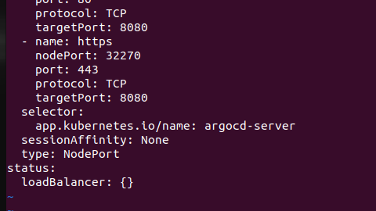

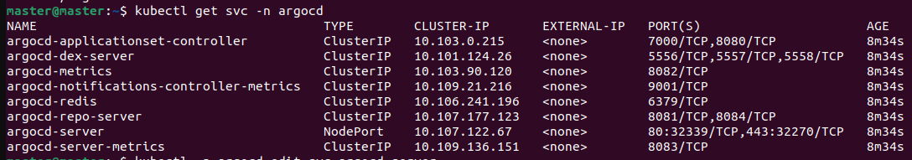

To access the ArgoCD console, use the IP address of any of your nodes along with the service port.,

In my case node ip address is 10.10.20.43 and service port is 31026.

[http://10.10.20.43:](http://10.10.20.58:32339)31026

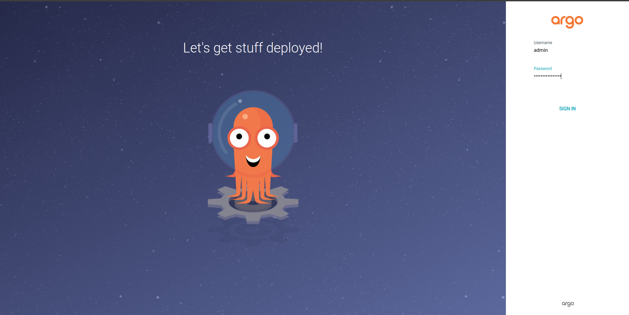

Enter a User name as admin,

And to get your password run this command

kubectl get secrets -n argocd argocd-initial-admin-secret -o yaml

You will get the password like this : djd3QjRPTnIyYU85cmx0bA==

(**Note:** before that make sure that your service is running fine)

You must convert this password to Base64

echo djd3QjRPTnIyYU85cmx0bA== | base64 -d

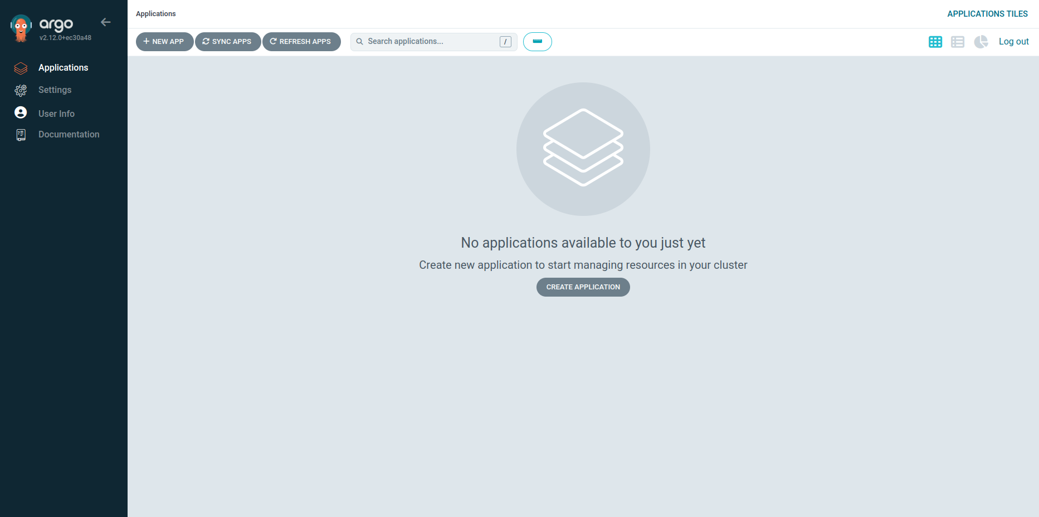

In this documentation we will deploy the simple nginx app.

First, go to settings, then select repository, and click on connect repo.

Then you'll see a page. Fill in the information like this:

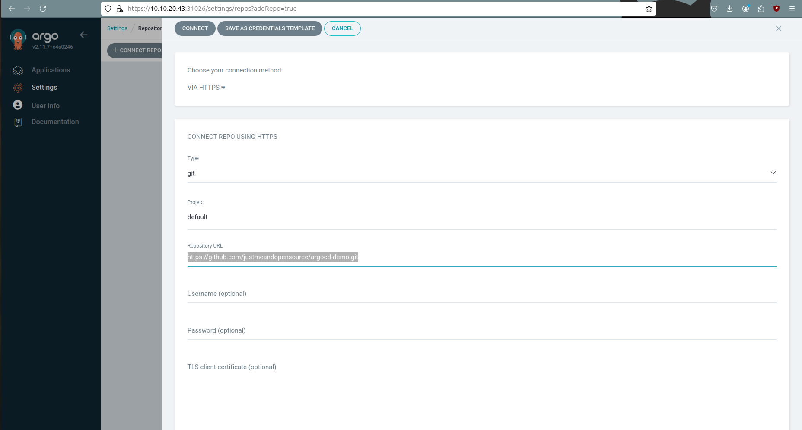

Then click on "Connect" at the top. Once the repository is connected, you'll see a page like this.

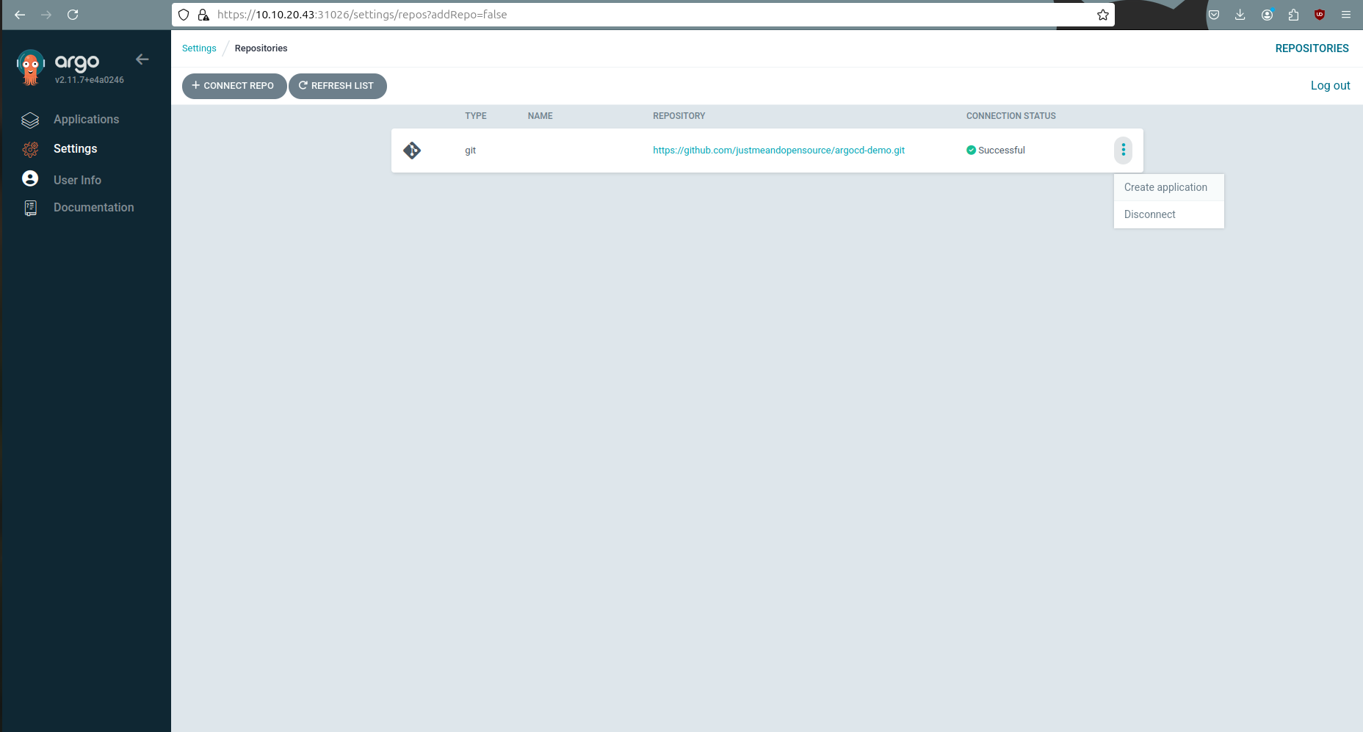

After creating the repository, click on the three dots menu. From there, you can create an application. You can also go to the "Applications" section in the sidebar. On that page, at the top, there's an option to create a new application.

After you click "Create Application," you'll see a page where you need to fill in the information like this.

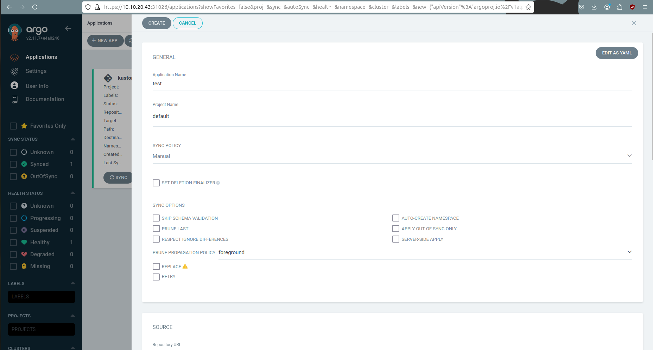

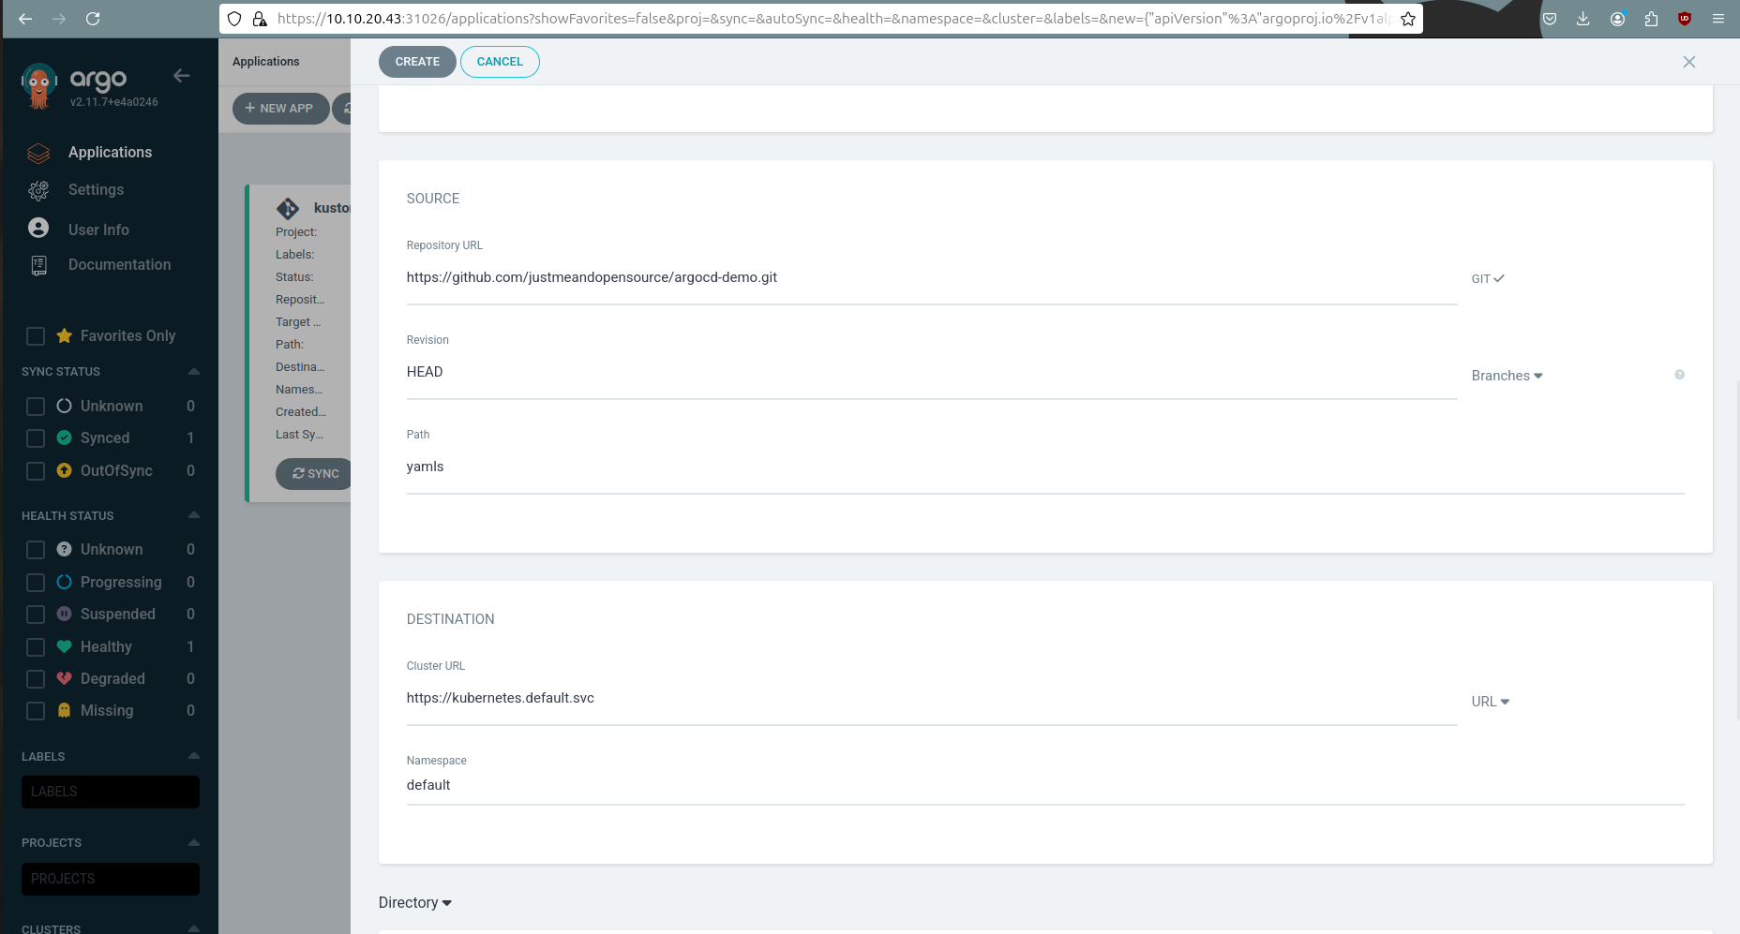

After you fill in the information and click the "Create" button, the new application you created will appear in your list of applications.

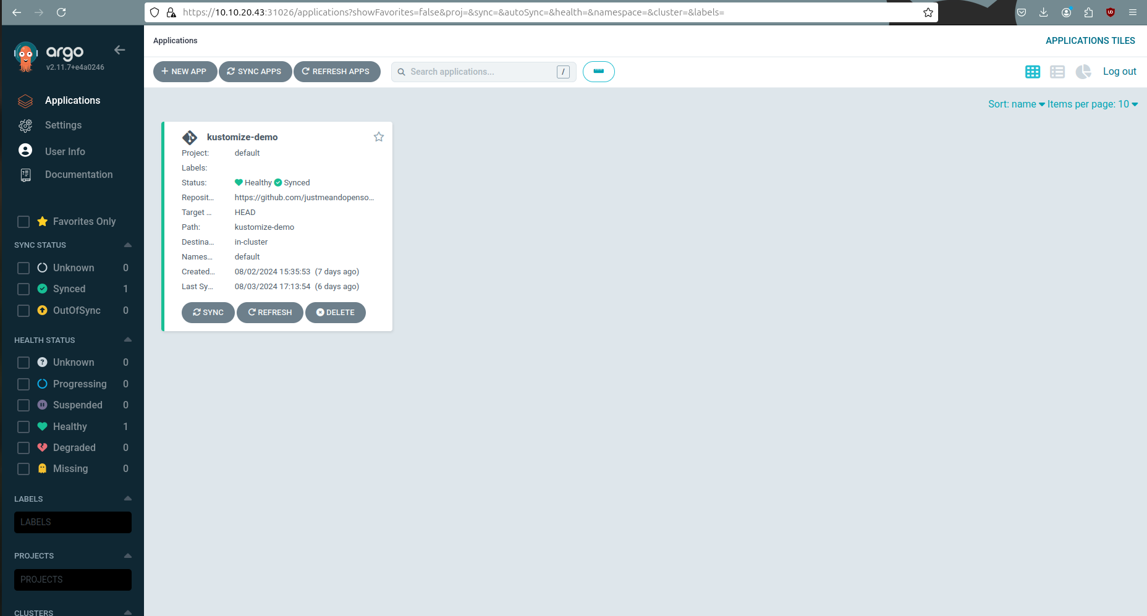

Now click on the application, and you'll see your Nginx application.

Initially the application is not sync, so for that you need to sync first.

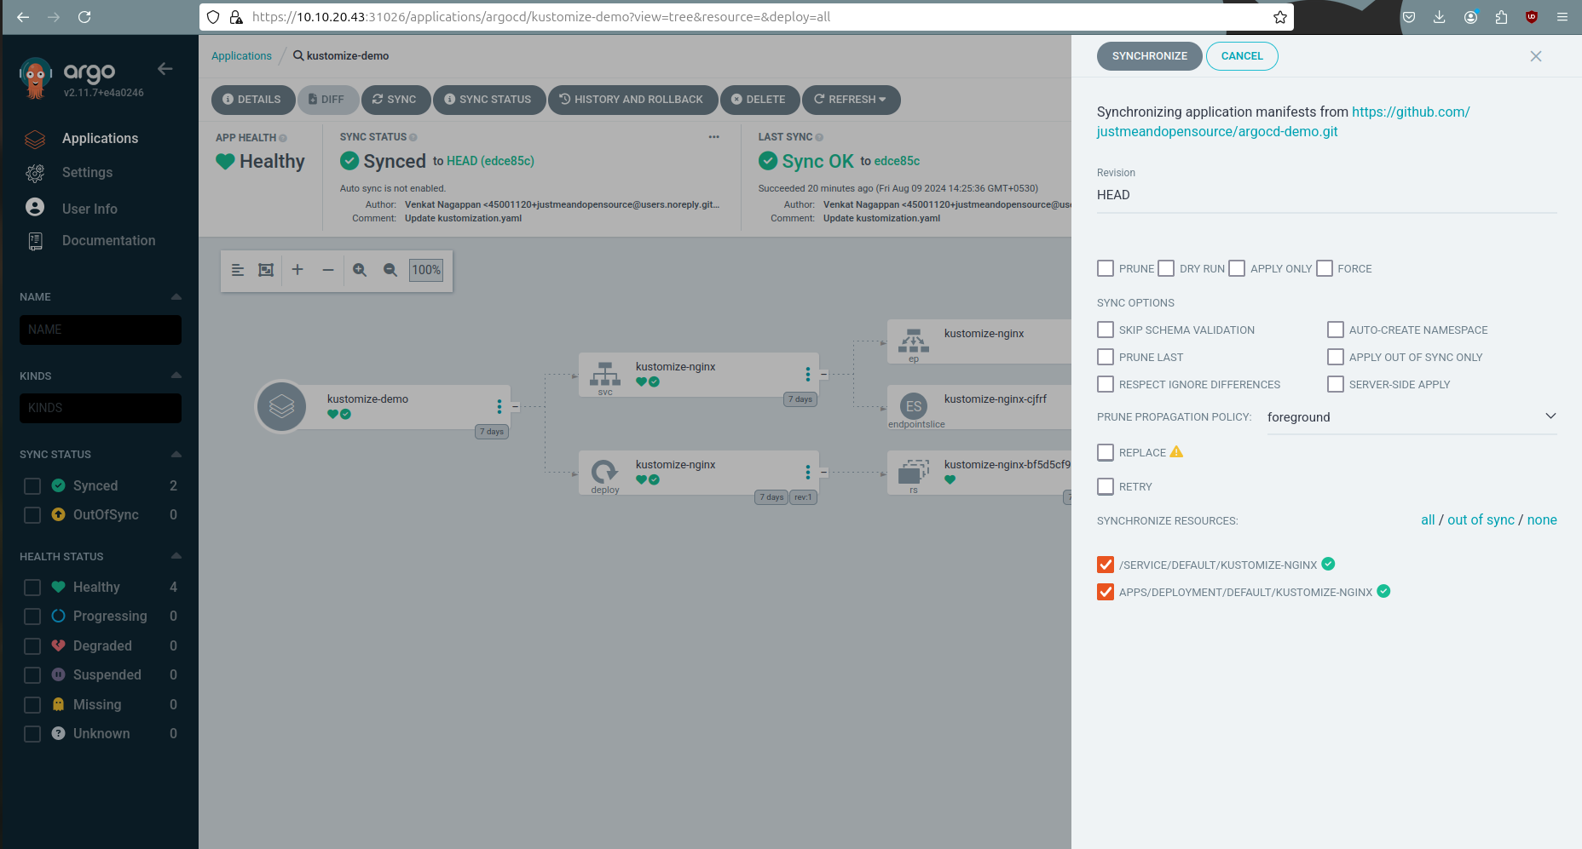

After syncing the application, you’ll see your Nginx deployment.

